
Wuhan
Britain-China School
CANDIDATE
NAME

CANDIDATE
CLASS
PHYSICS (Midterm) 0625/41
Paper 4 Theory (Extended) Nov 2025
1 hour
You must answer on the question paper.
No additional materials are needed.
For Examiner’s Use
1
2
3
4
5
6
7
8
Total

INSTRUCTION
      - Answer all questions.
      - Use a black or dark blue pen. You may use an HB pencil for any diagrams or graphs.
      - Write your name and class number in the box at the top of the page.
      - Write your answers to each question in the space provided.
      - Do not use an erasable pen, correction fluid or tape.
      - You may use a calculator.
      - You should show all your working and use appropriate units.
      - Take the weight of 1.0 kg to be 9.8 N (acceleration of free fall = 9.8 m / s²).

INFORMATION
- The total mark for this paper is 60.
- The number of marks for each question or part question is shown in brackets [ ].

A car of mass m is travelling along a straight, horizontal road at a constant speed v.
At time t = 0, the driver of the car sees an obstruction in the road ahead of the car and applies the brakes.
The car does not begin to decelerate at t = 0.
Explain what is meant by deceleration.

[2]
Suggest one reason why the car does not begin to decelerate at t = 0.

[1]
Fig. 1.1 is the distance–time graph for the car from t = 0.
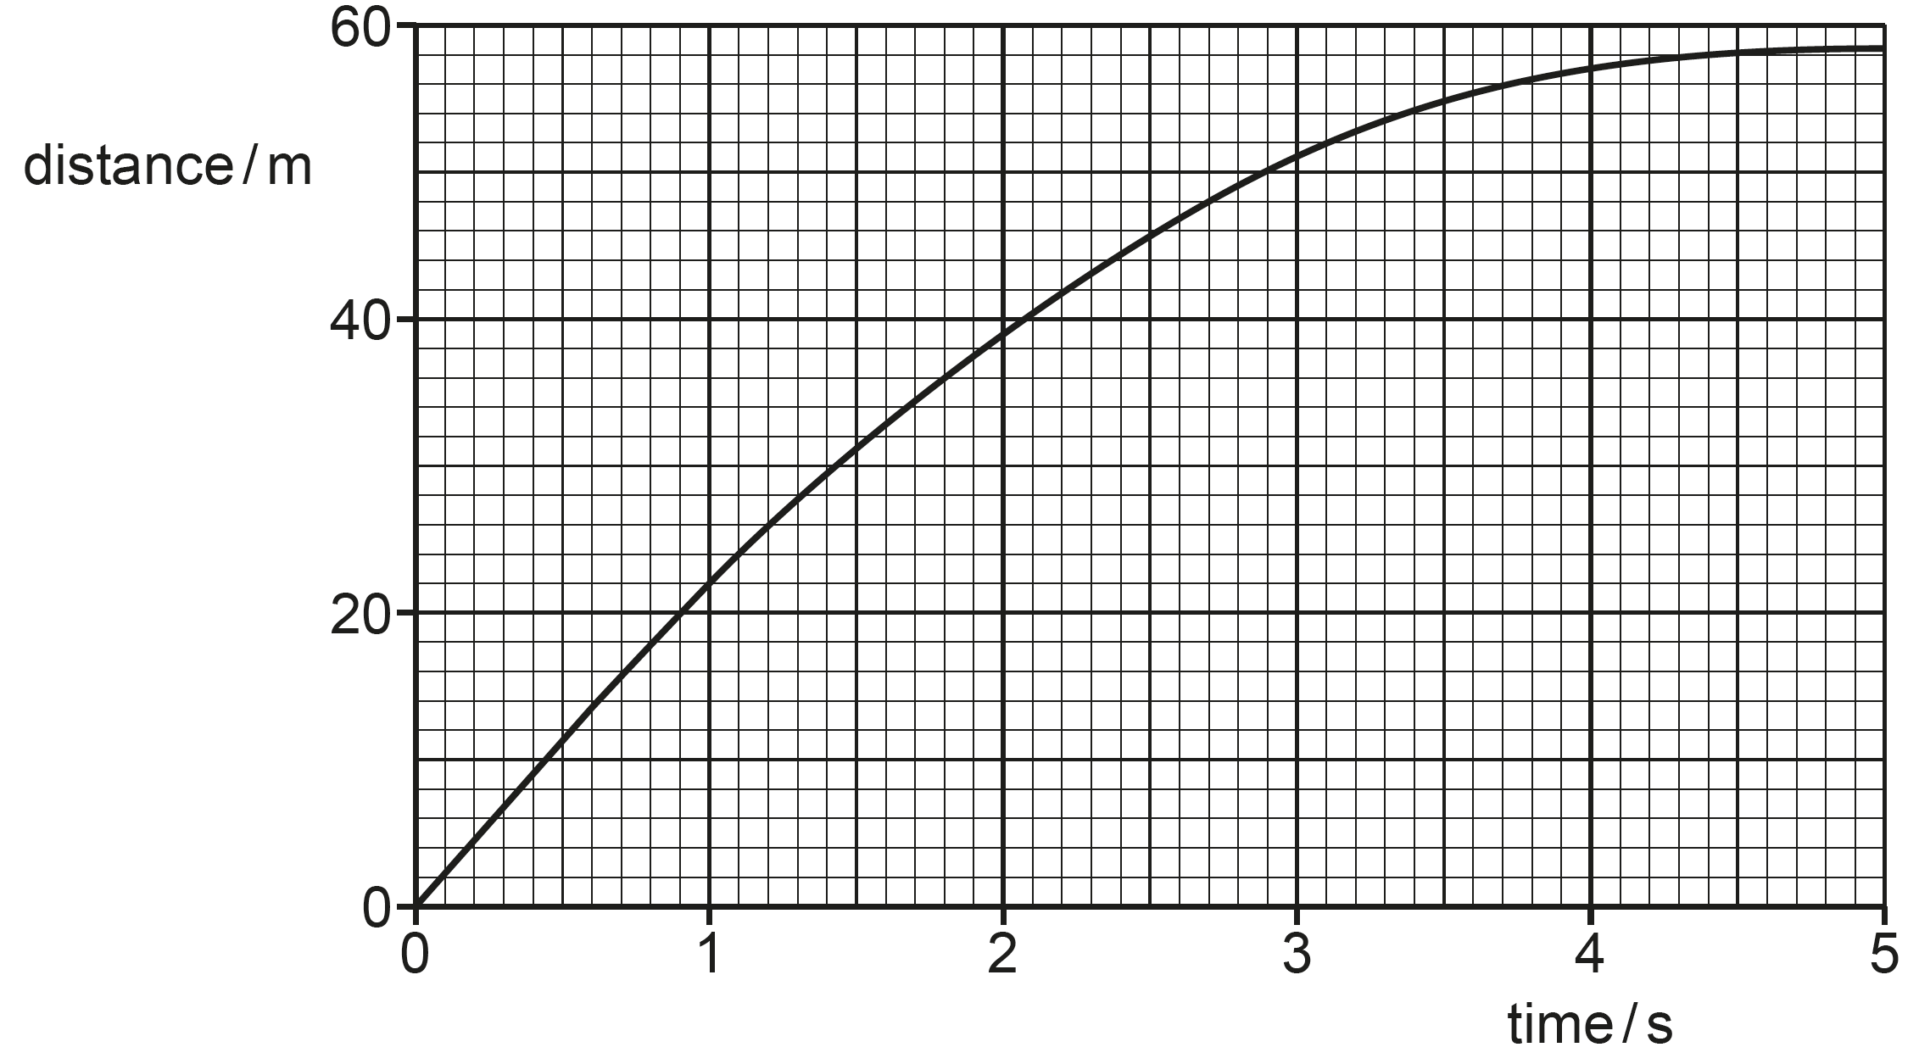
Fig. 1.1
State the property of a distance–time graph that corresponds to speed.
[1]
Using Fig. 1.1, determine the initial speed v of the car.

v = [2]

When the car is decelerating, there is a constant resistive force F on the car due to the brakes.
The deceleration of the car is greater than $\frac{\text{F}}{\text{m}}$ and is not constant.
Explain why:
the deceleration of the car is greater than $\frac{\text{F}}{\text{m}}$

[1]
the deceleration is not constant.

[2]
[Total: 9]

Define the moment of a force in words.

[2]
Write down the name of one man-made device in everyday use that depend, for its action, upon the moments of forces.
[1]
Fig. 2.1 shows a uniform rod AB acted upon by three equal forces F.
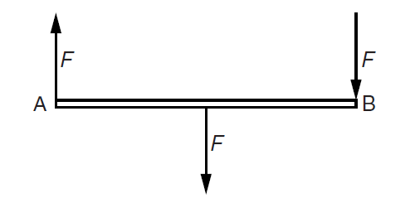
Fig. 2.1
State two reasons why the rod is not in equilibrium.
1.
2. [2]

Fig. 2.2 shows a uniform rod PQ, supported at its centre and held in a horizontal position. The length of PQ is 1.00 m.
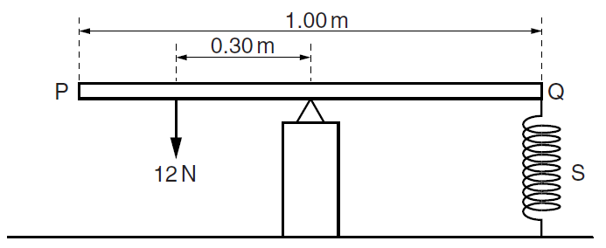
Fig. 2.2
A force of 12 N acts at a distance of 0.30 m from the support. A spring S, fixed at its lower end, is attached to the rod at Q. The spring constant of spring S is 2.5 N cm ⁻¹.
Calculate the force exerted on PQ by the spring.

force = [2]
Calculate the extension of spring.

extension = [2]
Explain why it is not necessary to know the weight of PQ.

[1]
[Total: 10]

Fig. 3.1 shows a space vehicle which consists of a capsule and a nose cone.
The space vehicle is moving at a velocity of 7800 m / s. The mass of the space vehicle is 840 kg.
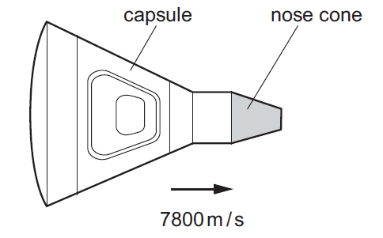
Fig. 3.1
Show that the momentum of the space vehicle is approximately 6.55 × 10⁶ kg m / s.

[1]
The capsule ejects the nose cone, as shown in Fig. 3.2.
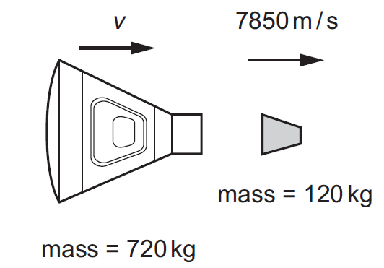
Fig. 3.2 (not to scale)
Determine the velocity v of the capsule after the nose cone is ejected.
Give your answer to 3 significant figures.

velocity v of the capsule = [3]

A different space capsule returns to Earth.
Fig. 3.3 shows this capsule just before it lands in the sea.
The capsule travels at terminal velocity.
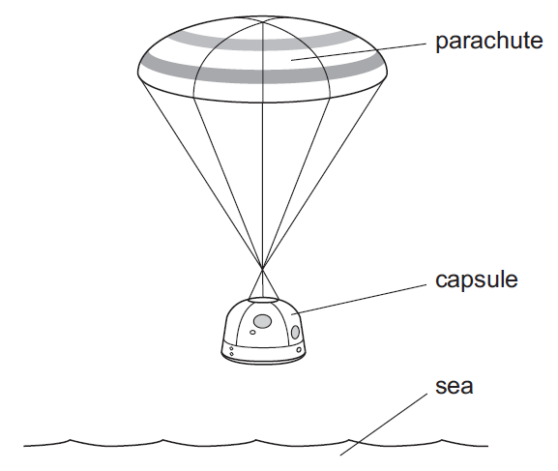
Fig. 3.3
The upward vertical force acting on the capsule is 120 kN.
Calculate the mass of the capsule.

mass of the capsule = [2]
[Total: 6]

Fig. 4.1 shows the cross-section of a barrage built across a tidal bay. The barrage is part of a tidal power station.
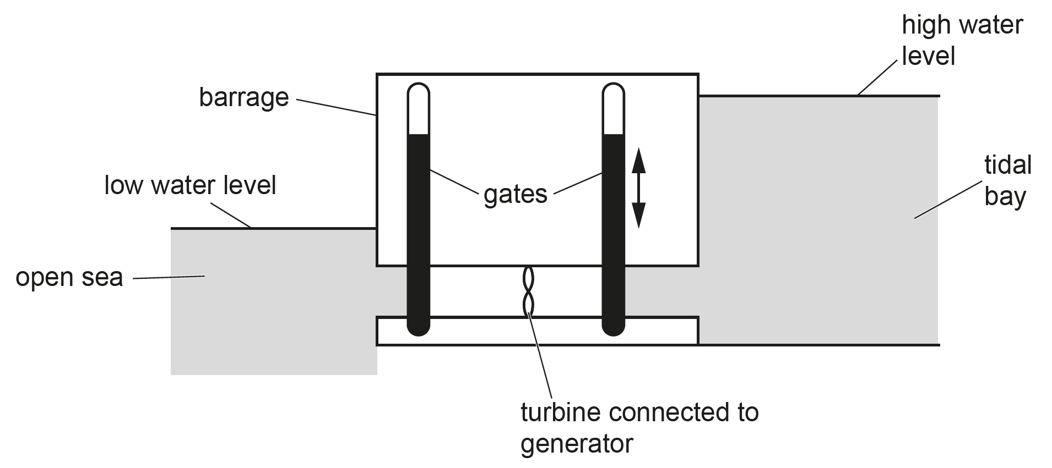
Fig. 4.1
The gates are raised to be open when the tide comes in. The gates are lowered to close when it is high tide. Fig. 4.1 shows the water levels in the open sea and the tidal bay when it is low tide. The gates are raised and water flows through the turbine.
Complete the sentences to describe the energy transfers which take place when the gates are opened. Use words from the list.
tidal bay kinetic gates gravitational potential
open sea turbines water
energy of the water in the is transferred to energy in the rotating . This energy is used in the generator to produce electrical power. [3]
State one advantage and one disadvantage of tidal power as an energy resource.
Advantage

Disadvantage
[2]
State the main source of energy for tidal energy.
[1]
[Total: 6]

Fig. 5.1 shows a side view of a large tank in a marine visitor attraction.
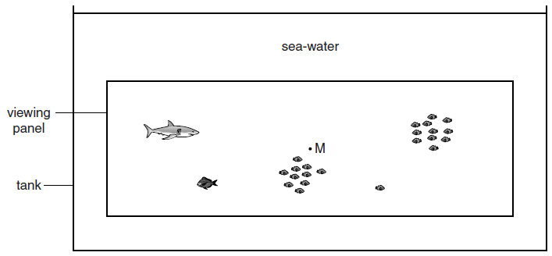
Fig. 5.1 (not to scale)
The tank is 51 m long and 20 m wide. The sea-water in the tank is 11 m deep and has a density of 1030 kg / m³.
Calculate the mass of water in the tank.

mass = [3]
The pressure at point M, halfway down the large viewing panel, is 60 kPa more than atmospheric pressure. Calculate the depth of M below the surface of the water.

depth = [2]
The viewing panel is 32.8 m wide and 8.3 m high.
Calculate the outward force of the water on the panel. Assume that the pressure at M is the average pressure on the whole panel.

force = [2]
[Total: 7]

BLANK PAGE

State one way in which the molecular arrangement of a gas differs from the molecular arrangement of a liquid.

[1]
Compressibility is the ease with which a substance can be compressed.
State and explain, in terms of the forces between the molecules, how the compressibility of a gas differs from that of a liquid.

[2]
Fig. 6.1 shows a weather balloon being inflated by helium from a cylinder.
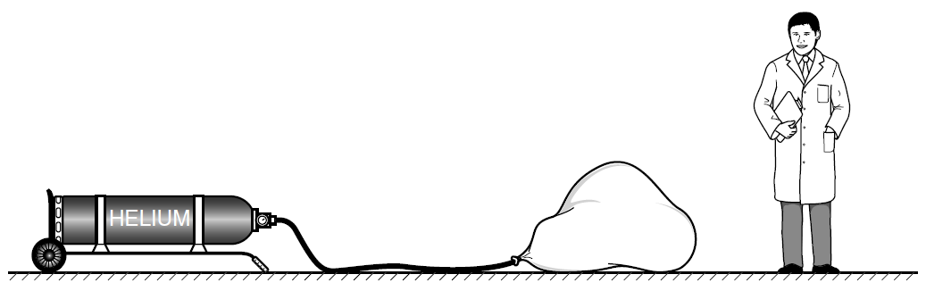
Fig. 6.1
The helium that inflates the balloon had an initial volume of 0.035 m³ at a pressure of 2.6 × 10⁶ Pa, inside the cylinder.
The pressure of the helium in the balloon is 1.0 × 10⁵ Pa and its temperature is the same as it was when in the cylinder.
Calculate the volume occupied by the helium in the balloon.

volume = [3]
As the balloon rises up through the atmosphere, the temperature of the helium decreases. State the effect of this temperature change on the helium molecules.

[1]
[Total: 7]

Fig. 7.1 shows a kitchen tap that supplies instant boiling water
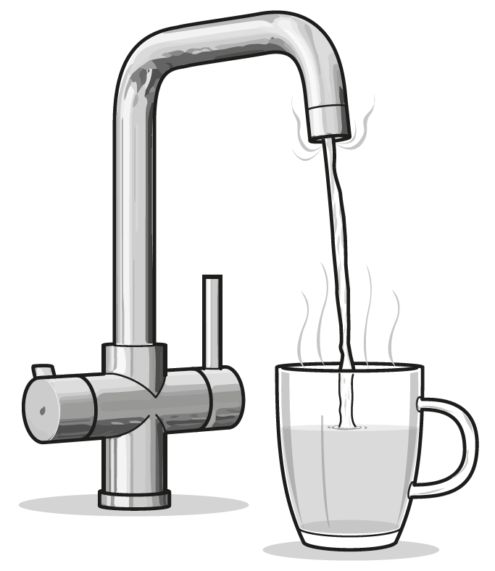
Fig. 7.1
Cold water passes over an electric immersion heater inside the tap.
The boiling point of water is 100 °C.
State the boiling point of water in Kelvin scale
K [1]
The immersion heater is powered by the mains at a voltage of 230 V. When the tap is opened, the heater switches on and the current in the heater is 13 A.
Calculate the thermal energy produced by the heater in 60 s.

thermal energy = [2]
The specific heat capacity of water is 4200 J / (kg °C). The cold water that enters the tapis at 22 °C. Calculate the rate at which water at its boiling point emerges from the tap.

rate = kg / min [3]
[Total: 6]

Describe how a longitudinal wave differs from a transverse wave.

[2]
Fig. 8.1 represents a seismic wave produced by an earthquake.

Fig. 8.1
State whether this seismic wave is a P-wave (primary) or an S-wave (secondary). Justify your choice.

[2]
The wave represented in Fig. 8.1 has a wavelength of 1.2 × 10⁴ m.
Calculate the actual distance between point J and point K.

distance = [2]
The wave in (ii) travels through the ground at a speed of 4600 m / s.
As the wave passes a certain point, the ground completes 5 oscillations.
Calculate the time that it takes for the wave to pass. Show your working.

time = [3]
[Total: 9]

